**CONTAINERIZE THE APP- DOCKER IMAGE CREATION**

|  |  |
| --- | --- |
| **TEAM ID** | **PNT2022TMID22972** |
| **PROJECT NAME** | **SKILL AND JOB RECOMMENDER** |

Create a Kubernetes cluster

* Sign in to your [IBM Cloud Dashboard](https://cloud.ibm.com/dashboard/apps/?cm_sp=ibmdev-_-developer-tutorials-_-cloudreg).
* Open **IBM Kubernetes Service**.

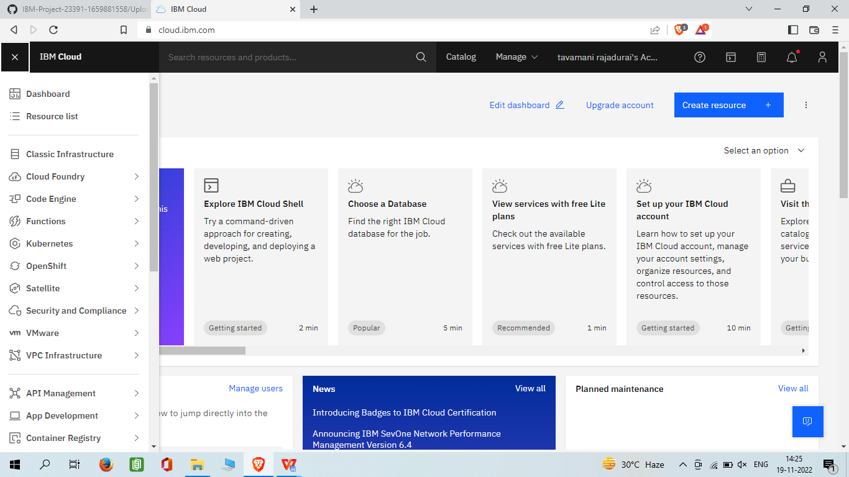

Click **Create Cluster**

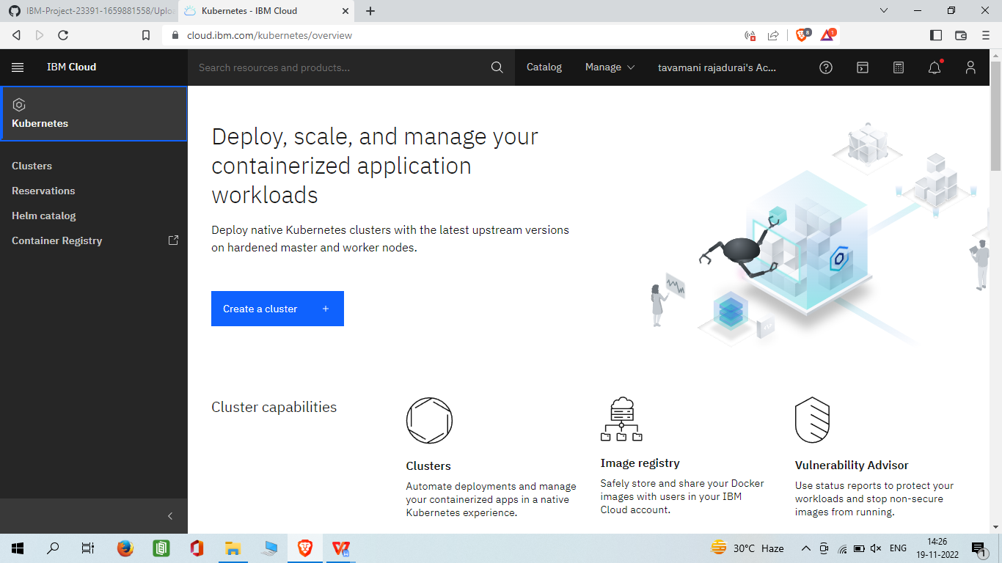

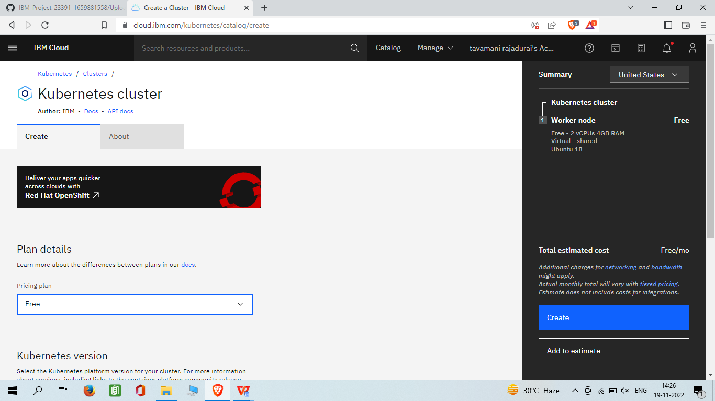

* Click on the **Worker Nodes** tab to note the cluster's Public IP.

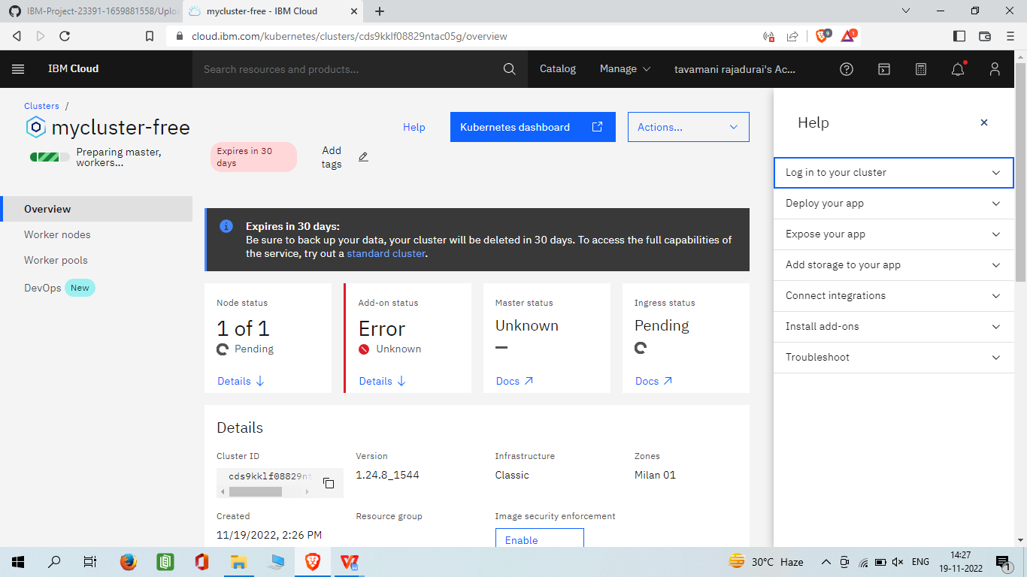

Containerize your Flask application

